Weather Station Project Documentation

Made By: Danil Gritsenko (TARpv17)

For: <https://github.com/Kristoferlatt/WeatherStation>

# What does the project include?

Devices: Thermometer, Light detector, LCD Screen, Arduino UNO, Button, Potentionmeter, Servo Motor, Red, Green and Yellow LEDs, Wires

Features: Showing current temperature and light levels with state levels (If too hot, shows ’hot’ on screen). Moving servo motor when the temperature reaches ’hot’ and ’overheat’ levels, Beeping buzzer when temperature reaches ’overheat’ level. Status lights – Green when everything is within normal levels, yellow if the temperature is hot or if it’s too bright/dark, red when the temperature reaches ’overheat’ level.

Edit mode – Allows to edit the temperature thresholds (cold, hot, overheat) and temperature mode (Celsius, Kelvin or Fahrenheit)

# How does it work?

Thermometer and Light detectors collect data, Arduino processes it and shows corresponding data on the LCD screen on the front, and changes LED lights accordingly to the temperature/light level.

There’s one-second cycles, updating the data and checking if the edit button is held. If it detects the edit mode button being held at the start of the cycle it skips the code to the edit mode section, where it begins a timer as well as allowing the user to edit thresholds for different temperature states, as well as changing the temperature units. Once the timer reaches 0, or the user reaches the end of editing by choosing a temperature mode (units), it begins the standard cycle, displaying the temperature and light levels accordingly, with current thresholds.

The temperature thresholds are as follows (By default) = Cold if under 18 degrees, Normal if between Cold and Hot, Hot if above 27 degrees and under Overheat, Overheat if above 30 degrees.

The light thresholds are as follows (By default) = Black if above 500, Dark if above 400, Normal if under Dark and above Bright, Bright if less than 80, Too bright if less than 50.

# Reference Pictures

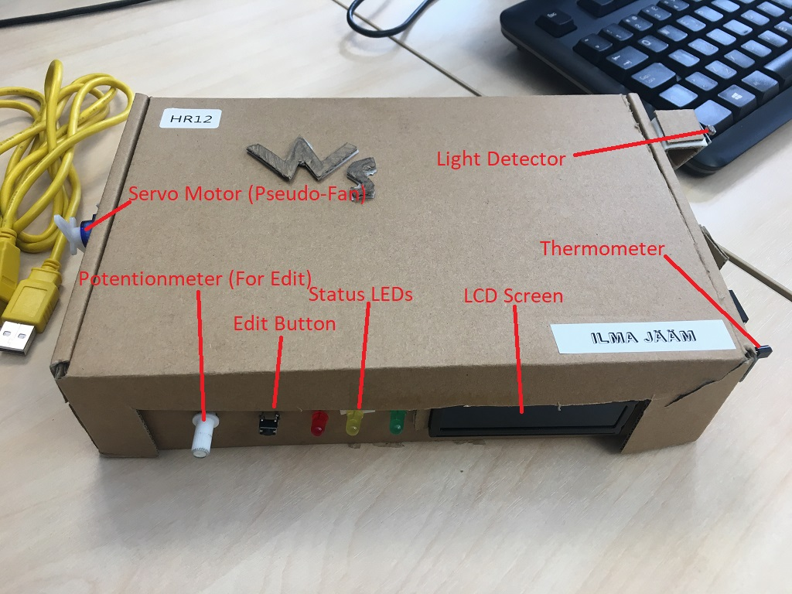

Picture - Front Closed

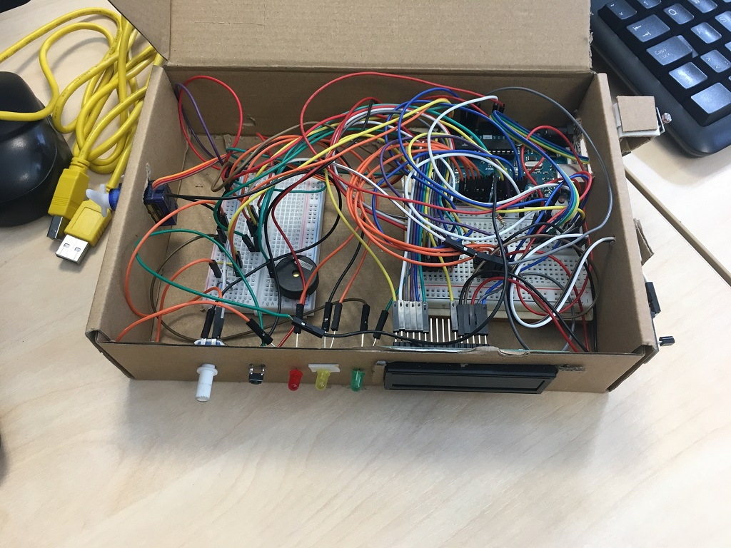

Picture - Front Open

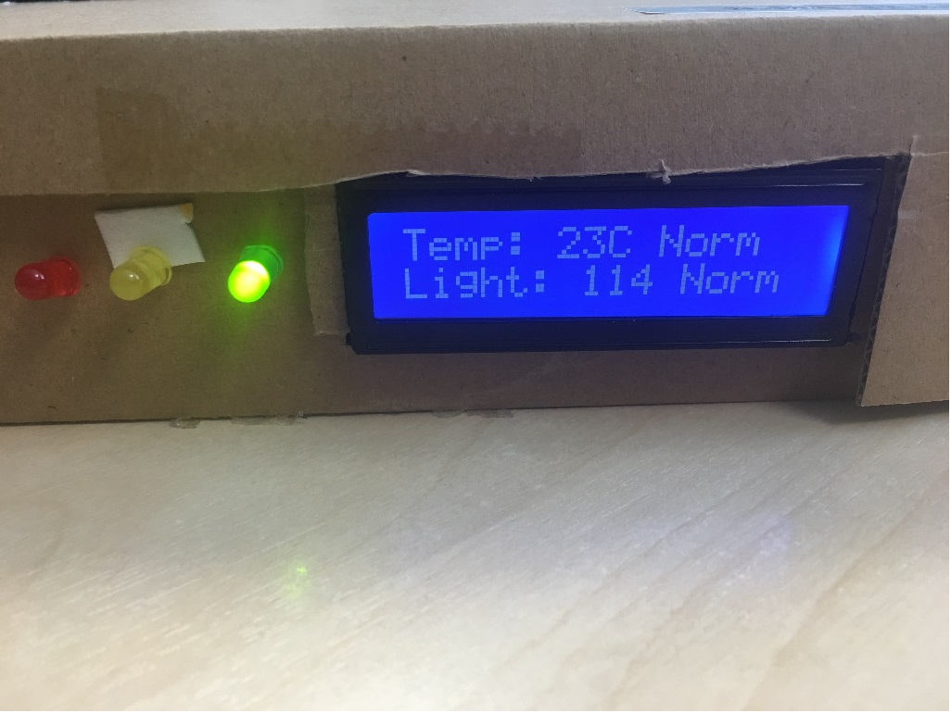

Picture - LCD Screen and Status Light in action

# How to use Edit Mode?

You can access Edit Mode by holding down the button, upon entering Edit Mode let go of the button and set the minimum threshold for ’Hot’ temperature level using the potentionmeter on the left, when done, hold down the button again and proceed the same actions for ’Overheat’, ’Cold’ and ’Temperature Mode’. Proceed with caution at Temperature mode, hold down the button for half-a-second to exit Edit mode, or wait out the timer. If done incorrectly you will enter Edit Mode immediately again, forcing you to re-input all values again.

## Values for Temperature Mode:

0 = Celsius

1 = Kelvin

2 = Fahrenheit

(Kelvin and Fahrenheit are not completely correct and may be not working correctly.)